
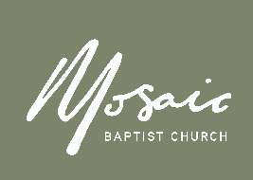
Incident Report Form
Report all incidents to the Church Office within 24 hours
E: office@mosaicbaptist.org.au Ph: 6254 6565
M: 0433 646 146

Date Reported |  | Date of Incident
Time of Incident
Ministry
Name of Person Filing this incident | Name  Address  Phone Email  Signature
Name of Person(s) Involved | Name  Address  Phone Email  Signature
Witnesses | Name  Address  Phone Email  Signature
Location of Incident
Describe the Incident
If someone was injured name them and describe their injuries
Likely Cause

Please explain what was done to assist them
What medical assistance was required?
1. First Aid
2. Medical Treatment
3. Hospitalisation

Office Use Only

Copies to the following
Does ACT WorkCover have to be contacted?
If yes – list date
Does the Baptist Union Insurance have to be contacted?
If yes – list date
Date the claim form has been sent
Does this need to be advised the next church meeting, if so when?

Completed By
Any Additional Notes
Action to be taken by the church
To be Actioned by
( Name & Date)

